

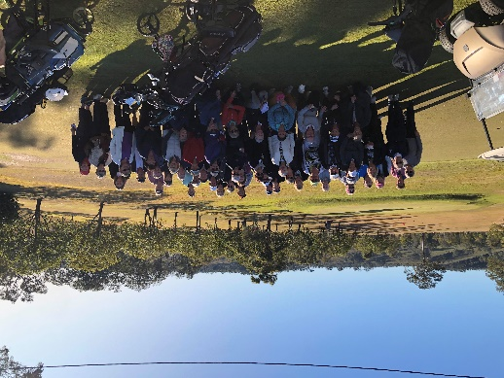**DUNGOG & DISTRICT**

**GOLF CLUB**

**98 Hanleys Creek Road Dungog**

**LADIES OPEN DAY**

**Sponsored by Loveys IGA Dungog &**

**Marcus Ryter, Branxton Golf Club Pro Shop**

**Monday 24th June 2024**

* ***SHOT GUN START: 8.30AM FOR 9.00AM TEE OFF***
* ***ENTRY FEE: $40.00 INCLUDES WELCOMING MORNING TEA, GREAT LUNCH, &***

***LOTS OF COUNTRY HOSPITALITY***

* ***LIMITED FIELD, FILLED IN ORDER OF ENTRIES RECEIVED***
* ***PAYMENT BY DIRECT DEPOSIT AT TIME OF ENTRY (Details below)***

**EVENTS:**

* ***INDIVIDUAL STABLEFORD EVENT - Divisions 1, 2 and 3\****
* ***MOST ACCURATE DRIVES BY DIVISIONS***
* ***NEAREST THE PINS BY DIVISIONS***
* ***LONGEST DRIVES BY DIVISIONS * Divisions based on Entries***

***Course: Par 72, Scratch 72, Slope Rating 124***

**ENTRIES CLOSE Wednesday 19th June 2024**

**DUNGOG & DISTRICT** **GOLF CLUB**

**LADIES OPEN DAY - Monday 24th June 2024**

**ENTRY FORM**

**Contact for groups: Name_______________________________ (for all correspondence)**

**email_____________________________________Phone #:________________________________**

|  |  |  |  |  |  |
| --- | --- | --- | --- | --- | --- |
| **Player Name** | **Golflink No: (10 digits)** | **Club** | **GA H/C** | **Special Dietary needs** | **Require cart / own cart / walk?** |
|  |  |  |  |  |  |
|  |  |  |  |  |  |
|  |  |  |  |  |  |
|  |  |  |  |  |  |
|  |  |  |  |  |  |
|  |  |  |  |  |  |
|  |  |  |  |  |  |
|  |  |  |  |  |  |

This form to be completed in full for each competitor and emailed to [dungoggolfclub@gmail.com](mailto:dungoggolfclub@gmail.com) by Wed 19th June 2024. **Enquiries to:** 0413925578

**Payment to:** Dungog Golf Club (Maitland Mutual)

BSB: 646 000 Account no: 100092044

Use reference: DLO+Surname,Club

**Tee Draw for Shotgun start will be posted on the day.**