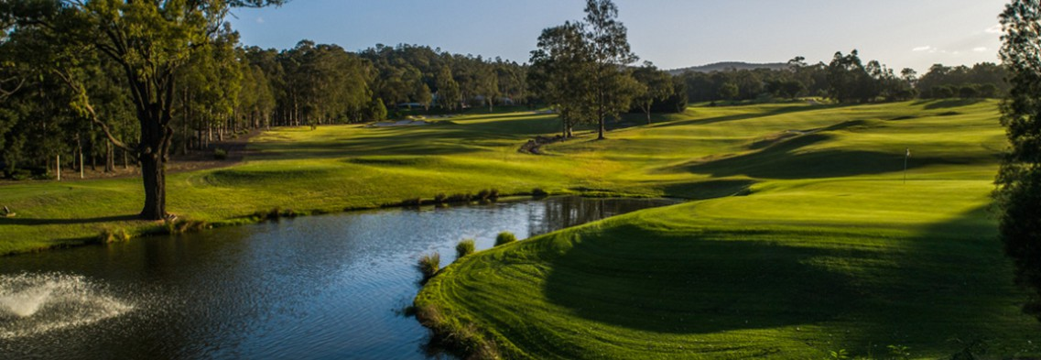

CYPRESS LAKES WOMEN'S OPEN DAY 2024

**Date:** Monday 17th June 2024

**Time:** 8:00am Registration - 9:00am Shotgun Start

**Format:** Individual Stableford 2 Divisions

**Cost:** $50pp inc cart - Payment details below

NTP 11th Hole + Long Drive 14th Hole Division Separation based on entries

MiScore App to be used - Presentation to follow in Cypress Bistro

**Entries Close:** 5pm Thursday 13th June 2024 - The Draw will be emailed out Friday 14th June

**Entries Via Email:** [cameronj@theoaksgroup.com.au](mailto:cameronj@theoaksgroup.com.au)

Name: Email:

Mobile Number: Home Club:

GoflLink No.: GA Handicap:

$50 Golf + Optional $15pp for Lunch (please tick one option) Chicken Caesar Wrap Sweet Chilli Chicken Wrap

 Salad Wrap  Soup with a Dinner Roll Gluten Free

Name on Card: Card Type: Amount: $50 or $65

Card No. / / /

Expiry / CCV