

**Hunter River District vs Newcastle District**

Played at Nelson Bay Golf Club – Saturday 22nd and Sunday 23rd July 2023

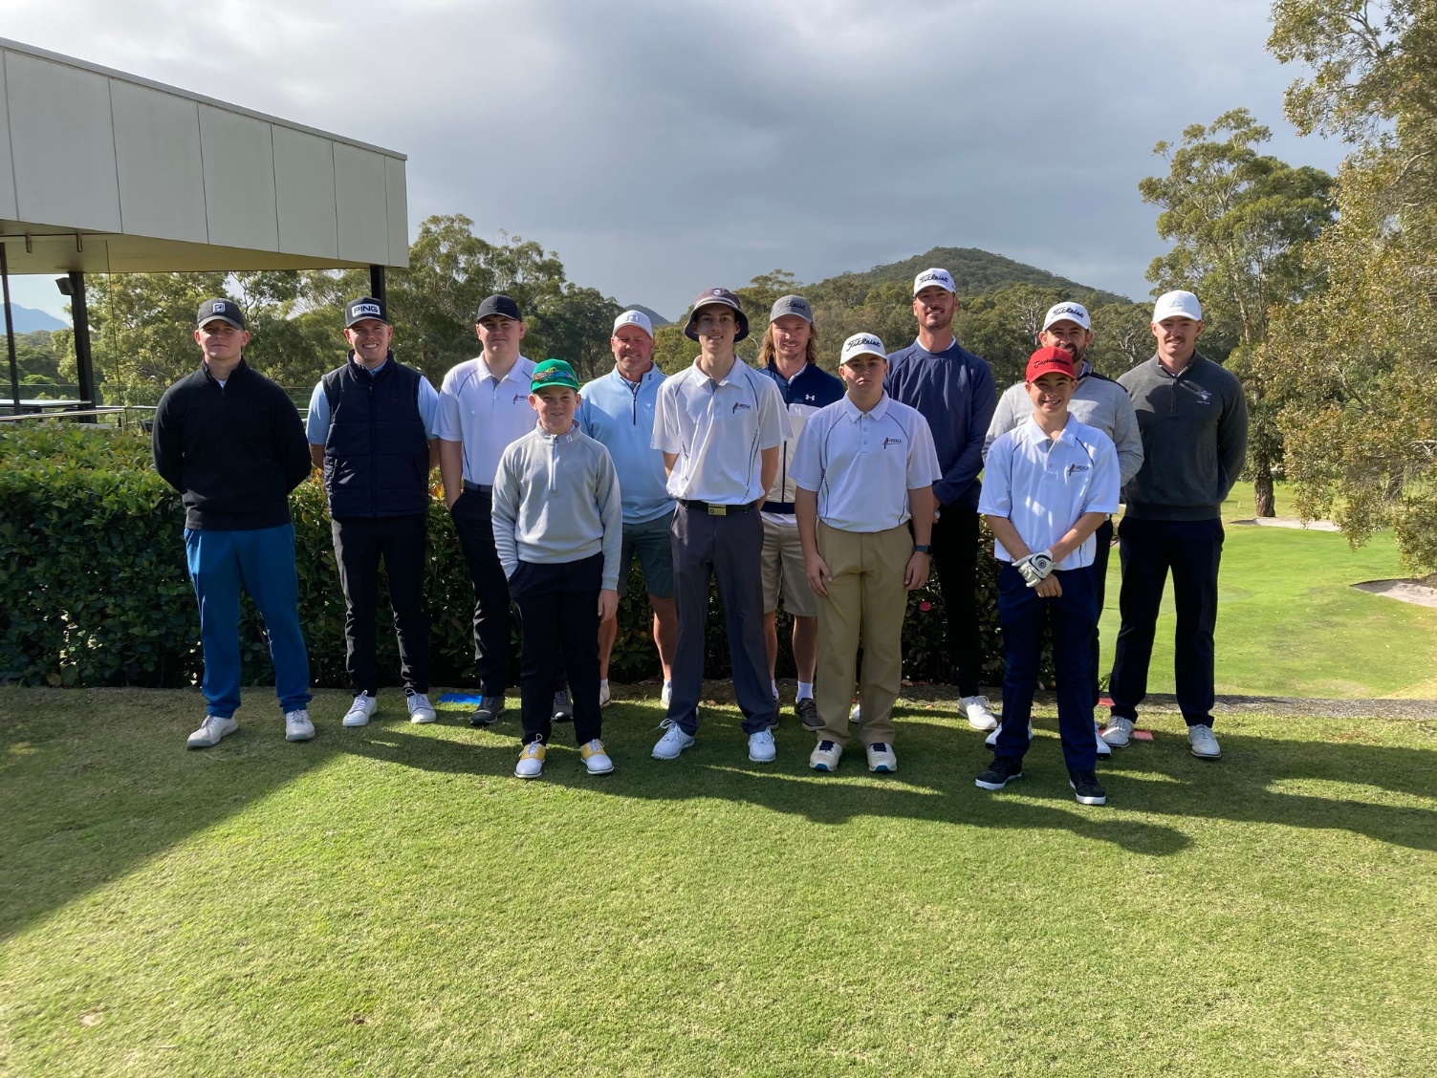

Another very enjoyable weekend. The four ball matches on Saturday were very close with Newcastle taking a 4 / 2 score line into the Sunday individual matches.

The senior’s division saw matches finish 3 all. In the juniors Newcastle came out on top 4 matches to 2

Overall score Newcastle 11 matches Hunter River 7 matches.

Weekend highlight was a hole in one for Hunter Junior Lachlan Standing.

Well played by the Hunter team, everyone had a very enjoyable weekend.

Thank you to Nelson Bay Golf Club for presenting the course in really good order, and the Newcastle DGA for the hospitality.

|  |  |  |  |  |  |
| --- | --- | --- | --- | --- | --- |
| **4 Ball Matches** | | | | | |
| **HRDGA** | | | **NDGA** | | |
| Matt Cluff | Lachlan Standing | +1 | Luke Ferrier | Toby Clune |  |
| Jack Clark | Travis Barber | 0 | Hamish Ellison | Jayden Butler | 0 |
| Matt Hill | Oliver Partridge |  | Chris Jardine | Lachlan Venables | 2/1 |
| Luke Waters | Harry Preece |  | David Alexander | Harvey Payne | 2/1 |
| Justin Ely | Taj Vesper |  | Oscar Gilson | Austin Hiskins | 2/1 |
| Josh Fuller | Bronx Geerin | 0 | Tom De Witt | Lachlan Lawson | 0 |
|  |  | 2 |  |  | 4 |

|  |  |  |  |
| --- | --- | --- | --- |
| **Singles Matches** | | | |
| **HRDGA** | | **NDGA** | |
| **SENIORS** | | | |
|  | Matt Cluff | Luke Ferrier | 5/4 |
|  | Matt Hill | Hamish Ellison | 3/2 |
| +1 | Jack Clark | Chris Jardine |  |
|  | Luke Waters | Oscar Gilson | 7/6 |
| 5/4 | Justin Ely | David Alexander |  |
| 4/2 | Josh Fuller | Tom De Witt |  |
| 3 |  |  | 3 |
| **JUNIORS** | | | |
|  | Bronx Geerin | Toby Clune | 5/4 |
|  | Oliver Partridge | Harvey Payne | 4/3 |
| 4/3 | Harry Preece | Lachlan Venables |  |
| 6/4 | Taj Vesper | Austin Hiskins |  |
|  | Travis Barber | Jayden Butler | 8/6 |
|  | Lachlan Standing | Lachlan Lawson | 4/3 |
| 2 |  |  | 4 |